[Skin Brightening Complex Cream](https://skyatransdermic.com/products/skin-brightening-complex-cream)

**A short engaging synopsis to accompany the product images**

Are you looking for a solution to address skin issues like dark spots, acne marks, hyperpigmentation, and melasma? Do you wish there actually were a potent cream that could tackle such skin issues? If your answer to either of these questions is in the affirmative, then the Skya Skin Lightening Cream is just what you are looking for!

The cream is an advanced formulation of clinically proven ingredients that tackle a variety of skin issues like dark spots, acne marks, hyperpigmentation, and melasma, among others. The cream’s bioactive content safeguards the skin’s lipid structures, providing a radiant glow. Devoid of chemical bleaching agents, the cream is dermatologically tested to yield superior results by balancing the melanin production of the skin cells and safeguarding them from the harmful effects of the sun’s UV radiation. An obvious choice for an even skin tone and a robust healing process, the Skya Skin Lightening Cream is the answer to a lot of skin woes.

**DETAILS**

**Composition:**

Purified Water, Lecithin, Lysolecithin, Lactobacillus Ferment, Niacinamide, 3-O-Ethyl Ascorbic Acid, Potassium Azeloyl Diglycinate, Bisabolol, Phytic Acid Tocopherol, Beta Sitosterol, Squalene, Zinc-oxide Hyaluronic Acid, Light Liquid Paraffin, Phenoxyethanol, Cetyl Alcohol, Cetostearyl Alcohol, Caprylyl Glycol, Caprylic Capric Triglycerides, Butylated Hydroxytoluene, D.M.D.M. Hydantoin, Carbomers, Disodium Edetate & Perfume.

**Know your product:**

**Listed in a bullet format with the bullets being visual icons of the skin benefit each pointer is talking about**

* **Lecithin: Acts as an antioxidant ensuring radiant skin**

Made of fatty acids, Lecithin is a lipid existing in the form of a thick, waxy substance. It contains choline, linoleic acid, alpha-linoleic acid, glycerol and traces of biotin. Lecithin permeates deeply into the skin, hydrating the skin in the process and strengthening its natural defenses. It changes the skin structure to help active substances penetrate deeper into the epidermis and its antioxidant properties fight the signs of aging.

*Source: <https://learncanyon.com/ingredients/lecithin/>

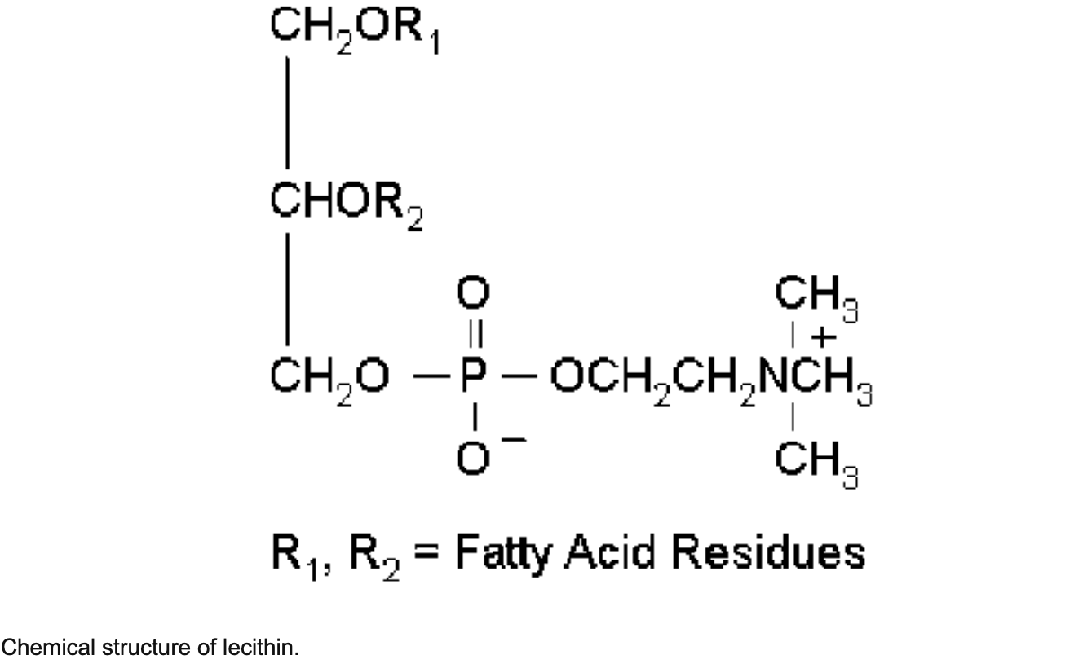

*Source: <https://www.researchgate.net/figure/Chemical-structure-of-lecithin_fig2_8213711>

* **Lysolecithin: Shields the skin’s natural lipid structures by promoting the delivery of active ingredients**

A commercial derivative of Lecithin (another ingredient of the SKYA Skin Brightening Complex Cream), Lysolecithin furthers the cause of Lecithin. It acts as an excellent emulsifier, and a moisturizing agent and enables enhanced penetration of active ingredients into the skin owing to its solubilising properties.

*Source: <https://www.ulprospector.com/knowledge/919/pcc-phospholipids/>

* **Lactobacillus Ferment: Conditions the skin owing to its antimicrobial properties**

A natural ingredient derived from probiotics, it is vegan, non-toxic, and comedogenic. Its many benefits include skin nourishment, enhanced texture, skin-brightening, and anti-ageing. It effectively tackles the bacteria on the skin’s surface that are responsible for causing infection and skin issues like inflammation.

*Source: <https://cosmetics.specialchem.com/inci-ingredients/lactobacillus-ferment>

* **Niacinamide: Inhibits melanin production by reducing the transfer of melanosomes**

Niacinamide inhibits the oxidative processes that are responsible for producing Amadori products. Amadori products are yellowish brown in colour that accumulate in skin matrix components like collagen as one advance in age; Niacinamide helps tackle the detrimental effects of such processes. Niacinamide also enhances the skin’s barrier function, decreasing the appearance of fine lines and wrinkles and promoting skin elasticity.

*Source: <https://www.ncbi.nlm.nih.gov/pmc/articles/PMC2921764/>

* **3-O-Ethyl Ascorbic Acid: The most stable form of Vitamin C, it stimulates collagen & DNA production while brightening the skin.**

Defending against environmental stressors, 3-O-Ethyl Ascorbic Acid boosts collagen production, reduces the signs of skin ageing making the skin look more plump and healthy. An etherified derivation of ascorbic acid, the chemical arrangement of this ingredient protects the 3-O group from ionisation thus preventing the molecule from ionisation. This makes it beneficial to tackle skin issues like uneven skin tone, hyperpigmentation, and provides protection from UV-induced immunosuppression and skin cancer.

*Source: <https://enclaire.in/article/3-o-ethyl-ascorbic-acid-the-skincare-superhero-for-a-radiant-glow>

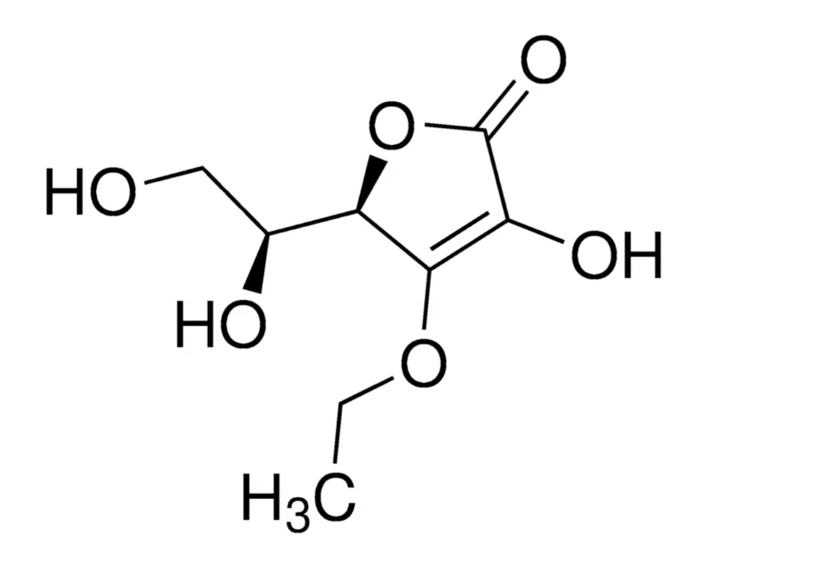

*Source: <https://www.sigmaaldrich.com/IN/en/product/aldrich/cds009203>

* **Potassium Azeloyl Diglycinate: Tackles inflammation, combats redness, acne marks and blemishes while hydrating the skin and regulating its sebum production**

Potassium Azeloyl Diglycinate is an innovative molecule that renders skin whitening and sebum normalising benefits. It also improves the stratum corneum elasticity. A new generation ingredient that is a combination of azelaic acid and glycerin, it is highly beneficial in taming adverse effects on sensitive skin and tackling issues of acne-prone skin.

*Source: <https://www.ncbi.nlm.nih.gov/pmc/articles/PMC3488300/>

**BICOWHITE  
(Upload with a separate image)**

Bicowhite® Complex is a multi-target delivery system that works in five different processes. These processes target the delivery of five different skin whitening ingredients that are the most effective on specific layers of the skin. These ingredients facilitate de-pigmentation processes, and curb the formation of dark spots to generate a gentle and effective even skin tone. Consisting of two lipid assemblies, Bicowhite® has proven to reduce the Melanin index and is also effective under UV radiation without producing photosensitivity. It functions with its two lipid assemblies – the internal smart discs carry the actives while the external lipid vesicle encloses these discs. This ensures that the active ingredients are doubly encapsulated. The vesicle helps deliver these smart discs to the skin that then travel through the intercellular spaces of the stratum corneum to reach the targeted skin layer. Smart discs are thus tailored to the affinity of the target skin layers.

**Bicowhite® Complex at a Glance**

* A multi-target delivery system
* Reduces melanin index
* Effective under UV radiation
* Non photosensitive
* Non irritant
* Clinically proven to reduce dark spots
* Can be used all year round
* Gentle on the skin
* Enable effective skin color unification
* Curbs de-pigmentation process, oxidation and inflammation
* Stunts formation of dark spots

*Source: <https://ultrachem.com/products/actives-and-biofunctionals/bicowhite/>

<https://skyatransdermic.com/products/skin-brightening-complex-cream>

<https://www.bicosome.com/bicowhite-3/>

**BENEFITS  
Can be listed in a format similar to the screenshot below with icons**

**1.** Suitable for all skin types

**2.** Makes the eye contours appear youthful & fresh

**3.** Helps smoothen fine lines & wrinkles

**4.** Cruelty-free

**5.** Water-resistant

**6.** Helps restore vitality

**7.** Paraben free

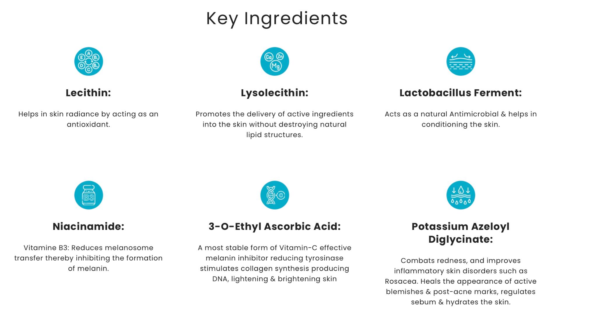

**HOW TO USE**

**Images used to be more representative of the target audience with crisp instructions**



Step I: Cleanse your face and pat dry gently

Step II: Apply a coined size amount of the cream on your face and neck

Step III: Massage it gently with your fingertips until it is absorbed into the skin

**More Information**

**Can instead be ‘Manufacturer Details’**

**User Reviews**

**Can also be ‘Hear From The Experts’ where doctors give a product testimonial**